Lily Raye
COM 598
2/9/2024

Heat Alerts Might not Reduce Deaths in Older Adults.
Article: https://www.sciencedirect.com/science/article/pii/S0160412021004591?via%3Dihub

Extreme heat is the top weather-related killer in the United States. As we continue to experience the growing impacts of climate change, heat waves will increase in length, frequency, and severity. This is extremely problematic because heat can affect our health in negative ways. Specifically, high temperatures and humidity can lead to hospitalizations and deaths linked to heart problems, dehydration, kidney issues, and more. To address these issues, it is important to issue heat alerts ahead of time to prepare people around the world for harmful health impacts. This study looked at the relationship between heat alerts and deaths, as well as hospital visits, to test the effectiveness of alerts on decreasing heat risk in older adults. Surprisingly, the authors did not find a correlation between heat alerts and reduced death counts in this study. Instead, they noted that deaths occurred and some older adults visited the hospital even on days with no heat alerts at all. This article showcased that, in order to reduce heat risk, we need to adjust the way we think about and issue current heat alerts.
This study initiated a nationwide analysis of heat alerts and their impacts on older adults in the United States. For example, death counts and hospital admission data within this population were collected throughout the summer months within the last twenty years. This information was then matched up with National Weather Service (NWS) heat alerts to determine the number of deaths and hospital visits in each US county that occurred on days with and without a heat alert. In addition, air pollution data and heat index (using humidity to understand what the temperature “feels like” outside) was analyzed with this same criteria. In order to gather the extreme impacts, only heat indices above 100 degrees Fahrenheit were considered. The authors used hospitalization and death data on any given day and compared the counts to heat alert and non-heat alert days. Throughout their study period, they did not find evidence that heat alerts decreased deaths in older adults. However, they found a positive relationship between alerts and certain hospitalization causes, such as fluid loss and heat related illnesses. This was especially true when a heat alert warned for heat index values over 100 degrees Fahrenheit or greater across the country. For other hospitalization causes such as kidney issues and chronic diseases, it didn’t really matter if a heat alert was issued or not. In other words, older adults sought medical care for these issues on cooler days, or when extreme heat was not in the forecast. Deaths were also not linked to the presence or absence of heat alerts, so it is important to look at the effectiveness of these preventative measures.
Even though heat alerts are meant to warn people ahead of time of harmful health impacts, they may not be effective for all populations and scenarios. For example, this article revealed that older adults might still experience greater health risks related to heat even when an alert is issued in their area. Since many heat alerts are received electronically, it is possible that older adults will not always receive these alerts if they do not have a phone or internet. Also, just because a heat alert is issued doesn’t mean someone will change their behavior accordingly in order to reduce their own health risks. For example, some older adults in the United States do not have access to air conditioning or other heat mitigation measures, so heat-related illnesses and deaths might still occur regardless of any warnings. As the authors mentioned, current NWS heat alerts in the country rely on vague heat index thresholds (heat index of 100 degrees Fahrenheit for northern communities and 105 degrees in southern communities). This could cause problems because not every region reaches these thresholds, so heat alerts might not be issued in all cases when risk is really present. Because of this, it is important to continue to evaluate heat alerts and their association with deaths and hospitalizations in different populations and regions nationwide.
As temperatures continue to rise across the world, it will become increasingly important to analyze how we respond to heat. To avoid heat-related deaths and illnesses, we must update heat alerts according to regional differences, socioeconomic groups, and health-related impacts. In this study, the authors did not find a relationship between heat alert issuance and a decrease in deaths in older adults. This is concerning because it suggests that these alerts might not be reaching our most vulnerable populations. In addition, this article mentioned that many of the heat alerts were, in fact, tied to increased heat-related hospitalizations. This demonstrates the importance of using data other than death counts to determine heat risk, as hospital visits also reveal health issues tied to heat. While heat alerts help us prepare ahead of a heat wave, they are imperfect, and future modifications are needed as climate change shifts what is classified as dangerous heat. By using region and demographic specific health and climate data, we can better prepare all citizens for the impacts of extreme heat. 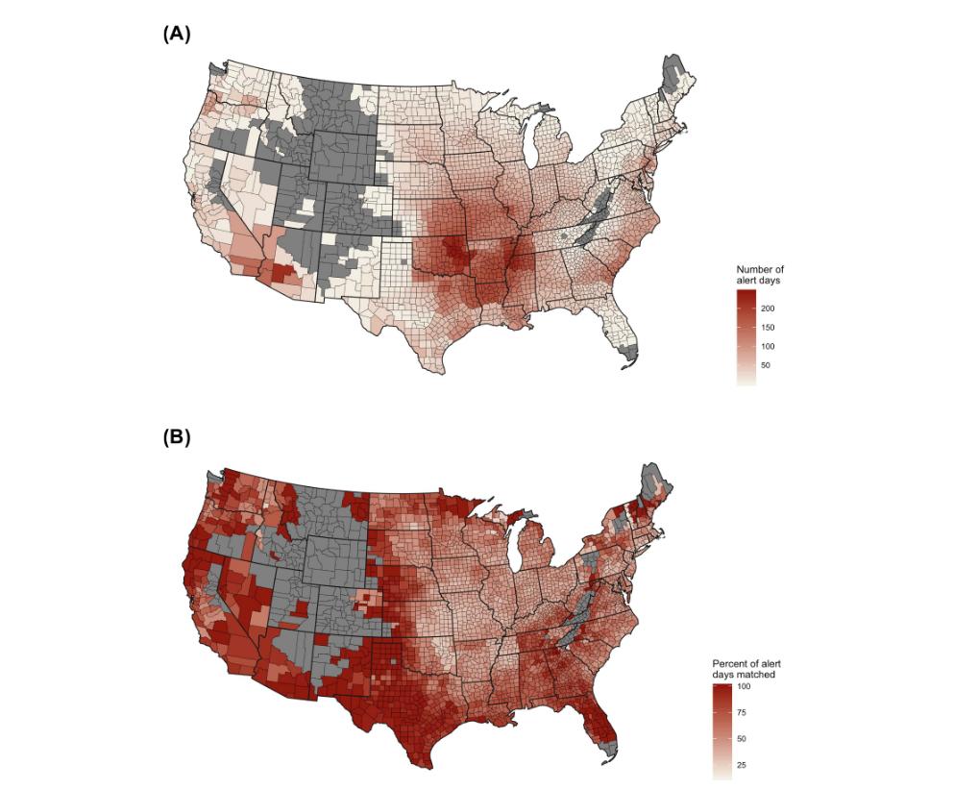
Figure 1. The top map of the United States displays the number of days with a heat alert issued for every county from 2006-2016 (A). Darker reds indicate higher numbers of alerts issued, while gray counties represent areas where no alerts were issued. The bottom map of the United States shows the counties where heat-related hospitalizations and deaths were reported without a heat alert issued (B). Darker reds indicate higher hospital visits on days without any alerts, while gray colors represent counties where no heat alerts were issued nor hospitalizations recorded.

